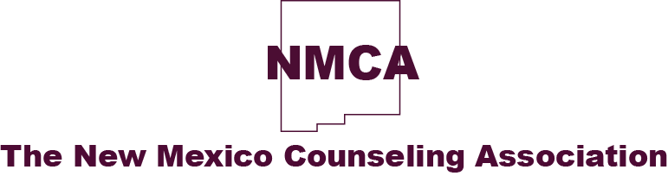

NMCA Nominations for the Ralph M. Garcia Award
In Memory of Ralph M. Garcia
In 2014, NMCA started the Ralph M. Garcia Memorial Membership Award. Ralph was a Counselor with Eight Northern Indian Pueblos Circle of Life Behavioral Health Network. He passed away on December 16, 2013. Ralph was a tribal member of Santo Domingo Pueblo and worked with many Native American Behavioral Health Programs helping clients with culturally focused healing methods. The Memorial Membership Award is awarded to a Native American Counselor who exemplifies Ralph's helping philosophy. The recipient is given a membership to NMCA for one year. Thanks to a scholarship set up by NM Advocates for Social Justice the recipient will attend the NMCA Annual conference for free.
The presentation of the award will take place at the NMCA conference (more info can be found here), so attendance is required. The Awards Committee is now accepting nominations at nmca.info@gmail.com with Ralph Garcia in the subject line.
Nominations must contain a 350-word explanation (minimum) as to why the nominee is deserving of the award. All entries must include nominee's resume, phone, email addresses, and licensures held. We ask that the person nominating them also provide their phone, email, and address.
Please use the email above for any questions. The Award Committee will notify the winner 45 days prior to the annual conference. The nomination deadline is January 28, 2018.
Accepting Nominations for 2018 @ nmca.info@gmail.com

